



3D Printer Material Prediction Using Machine Learning

SmartInternz

[www.smartinternz.com](http://www.smartinternz.com/)

**3D Printer Material Prediction Using Machine Learning**

**Abstract**

Additive manufacturing, commonly known as 3D printing, has brought a major transformation to the world of manufacturing. It allows for fast prototyping, customization, and the production of complex parts with great precision. However, one of the key challenges in 3D printing is selecting the right material for a specific printing task. This decision depends on many factors such as temperature, vibration frequency, printing speed, and how well each layer of material sticks to the previous one.

In this project, we aim to solve this problem by using machine learning. We have developed a predictive model that can help identify or recommend the most suitable printing material based on various process and sensor data. The dataset we used comes from a 3D printer equipped with a vibration sensor, which records real-time information during the printing process.

Using this data, we trained a supervised machine learning model to classify different materials. The goal of our system is to support manufacturers by improving material selection, optimizing printer settings, enhancing the overall print quality, and reducing the need for repeated trial-and-error testing. This approach can save both time and resources, making 3D printing more efficient and reliable.

**Project Flow**

This project follows a structured approach to build a machine learning system that predicts or classifies the material used in a 3D printer based on sensor data. The overall process is divided into multiple steps, from understanding the problem to building a model, testing its performance, and finally deploying it for real-time use. Here's how the flow works:

**System Interaction Overview:**

* The user interacts with a **web-based interface (UI)** to input values or parameters related to the 3D printing process (e.g., temperature, vibration, speed).
* These inputs are sent to a **machine learning model** integrated into the backend.
* The model **analyzes the input data** and returns the predicted material type.
* The **predicted result is displayed on the UI** for the user to view.

**Step-by-Step Activities:**

**1. Define the Problem**

* **Specify the business problem**: Understand why predicting the right material is important for improving print quality and efficiency.
* **Business requirements**: Identify what the system must do to be useful to manufacturers and engineers.
* **Literature survey**: Research similar work done in this field using machine learning for 3D printing or material classification.
* **Social or business impact**: Explain how this solution can help industries reduce cost, waste, and time spent on trial-and-error.

**2. Data Collection & Preparation**

* **Collect the dataset**: Obtain data from a 3D printer equipped with sensors (e.g., vibration sensors, temperature logs).
* **Data preparation**: Clean the data by handling missing values, outliers, and formatting issues to make it suitable for model training.

**3. Exploratory Data Analysis (EDA)**

* **Descriptive statistics**: Use summary statistics to understand key properties of the data.
* **Visual analysis**: Create graphs, charts, and plots to visually explore patterns and relationships in the dataset.

**4. Model Building**

* **Train the model**: Use different machine learning algorithms (e.g., Decision Trees, Random Forest, SVM) to train on the prepared data.
* **Test the model**: Evaluate how well the model predicts material types using a separate test dataset.

**5. Performance Testing & Hyperparameter Tuning**

* **Evaluate performance**: Test the model using various metrics such as accuracy, precision, recall, and F1-score.
* **Compare and improve**: Fine-tune the model using hyperparameters and compare results before and after tuning.

**6. Model Deployment**

* **Save the best model**: Export the trained model using a format like .pkl for reuse.
* **Integrate with a web framework**: Build a Flask-based web application that allows users to interact with the model via a web interface.

**7. Project Demonstration & Documentation**

* **Record an explanation video**: Demonstrate the working of the project from start to finish.
* **Prepare documentation**: Create a complete written report detailing all the steps followed in the project, including code explanations, visuals, and results.

**Milestone 1: Define Problem / Problem Understanding**

Activity 1: Specify the Business Problem

In additive manufacturing (3D printing), selecting the right material for a specific print job is crucial for ensuring the durability, precision, and quality of the final product. Currently, this decision-making process relies heavily on manual expertise, experimentation, and trial-and-error, which can be time-consuming, inefficient, and prone to error. With the increasing variety of printable materials available—such as PLA, ABS, PETG, and Nylon—there is a growing need for a data-driven approach to make informed material choices.

This project aims to solve this problem by developing a machine learning model that can predict or recommend the most suitable 3D printing material based on process parameters like vibration, temperature, printing speed, and layer adhesion. The model will help users and manufacturers reduce guesswork, optimize printer performance, and ensure higher success rates for print jobs

Activity 2: Business Requirements

A material prediction system for 3D printers will need to meet several key business requirements to be effective and practical in real-world use. These include:

* **Accurate and up-to-date recommendations:**  
  The system should use recent and relevant data collected from 3D printers (via sensors) to ensure accurate material predictions.
* **Adaptability and scalability:**  
  The model should be flexible enough to incorporate new types of materials and updated sensor data as the technology evolves.
* **Real-time integration:**  
  The prediction system should integrate with existing 3D printer systems or dashboards to provide real-time material suggestions during setup.
* **User-friendly interface:**  
  A simple, intuitive UI should be developed so that even users without deep technical knowledge can input parameters and receive material recommendations easily.
* **Cost and waste reduction:**  
  The system should help minimize material wastage and reduce the number of failed prints, leading to cost savings for both small and large-scale manufacturers.

Activity 3: Social or Business Impact

**Social Impact:**  
By reducing failed prints and helping select the right materials efficiently, this system can improve the accessibility of 3D printing for small businesses, educational institutions, and individual creators. It also promotes sustainable manufacturing by reducing material waste and energy consumption.

**Business Impact:**  
This project can significantly improve productivity and reduce operational costs in industries that rely on 3D printing, such as automotive, aerospace, and healthcare. Manufacturers can ensure higher product quality with fewer resources, enabling faster product development cycles and increased competitiveness in the market

**Milestone 2: Data Collection & Preparation**

Machine learning models depend heavily on the quality and structure of the data used to train them. In this milestone, we focus on collecting the appropriate dataset and preparing it for analysis and model training. This includes reading, cleaning, and understanding the data through both statistical and visual methods.

Activity 1: Collect the Dataset

To build an effective predictive model for 3D printer material classification, we require a dataset that captures the key physical and sensor parameters during the 3D printing process. These may include:

* Vibration frequency
* Printing temperature
* Printing speed
* Nozzle flow rate
* Layer adhesion quality
* Time-based sensor readings

For this project, we have used a .csv dataset containing readings collected from a **vibrational sensor mounted on a 3D printer** during multiple print jobs. Each entry is labeled with the material type being printed (e.g., PLA, ABS, PETG, etc.).

**Dataset Link :https://www.kaggle.com/datasets/shivamk21/vibrational-sensor-data-for-3d-printer-monitering**

Activity 1.1: Importing the Required Libraries

We begin by importing all the essential Python libraries required for data loading, cleaning, analysis, and visualization:

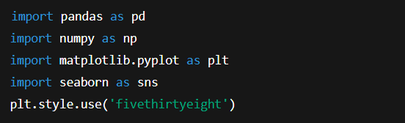

Activity 1.2: Reading the Dataset

To load the dataset into a pandas DataFrame, use the read_csv() function:



This function reads the .csv file and stores it as a Data Frame. Always inspect the first few rows using:

This helps understand the structure, features, and labels of the dataset.

**Activity 2: Data Preparation**

After loading the data, we need to clean and prepare it to ensure that it is suitable for training a machine learning model. Raw sensor data often contains noise, missing values, or outliers that must be handled.

**Activity 2.1: Handling Missing Values**

To check for missing (null) values:

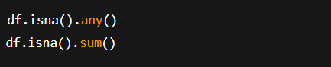

If any feature contains a significant number of missing values, we can handle them by either:

* Dropping rows with missing data
* Replacing with statistical measures (mean, median, or mode)
* Using interpolation or imputation techniques

In our dataset, no missing values were found. Therefore, we can skip this step for this specific dataset.

**Activity 2.2: Handling Outliers**

Outliers can distort model predictions and must be identified and handled properly. We use **boxplots** for visualization:



If outliers are present in a feature like vibration_frequency, we calculate the **Interquartile Range (IQR)**:

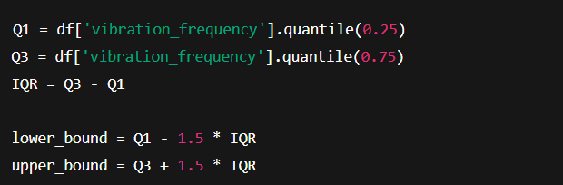

To handle the outliers, we apply a **log transformation**:



**Milestone 3: Exploratory Data Analysis**

Exploratory Data Analysis (EDA) is a crucial step in any machine learning project. It helps in understanding the structure, patterns, and relationships within the dataset. In this milestone, we explore the dataset using both statistical summaries and visual techniques to gain useful insights that inform model design and feature selection.

Activity 1: Descriptive Statistical Analysis

Descriptive statistics allow us to understand the basic properties of the dataset. We use the describe () function from the pandas library to calculate:

* Mean
* Standard deviation
* Minimum and maximum values
* Percentiles (25%, 50%, 75%)

This helps to identify the central tendency and dispersion of numerical features such as:

* Vibration frequency
* Nozzle temperature
* Printing speed
* Material layer thickness

**Activity 2: Visual Analysis**

Visualizing the data helps to identify hidden trends, outliers, and relationships that may not be obvious from statistics alone. We used the Seaborn and Matplotlib libraries for plotting.

**Activity 2.1: Univariate Analysis**

Univariate analysis focuses on one feature at a time.

* **Count plot for Material Classes:**



This shows the distribution of different materials like PLA, ABS, PETG, etc.

* Histogram of Vibration Frequency:



* **Pie Chart for Temperature Ranges:**



* This chart displays the composition of low, medium, and high nozzle temperature categories.

Activity 2.2: Bivariate Analysis

Bivariate analysis examines the relationship between two variables.

* **Barplot of Speed vs Material Type:**

sns.barplot(data=df, x='material_type', y='print_speed')

We observed that PLA is generally printed at higher speeds, whereas ABS and Nylon tend to be slower due to temperature and adhesion requirements.

* **Boxplot of Layer Thickness vs Material Type:**

sns.boxplot(data=df, x='material_type', y='layer_thickness')

This shows the spread of layer thickness across different materials and highlights any outliers.

Activity 2.3: Multivariate Analysis

Multivariate analysis helps uncover relationships among three or more variables.

* **Correlation Heatmap:**



* From the heatmap, we observed:
  + Strong correlation between vibration_frequency and print_speed.
  + High correlation between temperature and layer_adhesion_score.

Highly correlated features may cause redundancy and can be dropped or combined using feature selection techniques.

**Encoding Categorical Features**

Most machine learning algorithms require numerical inputs. Categorical data (e.g., material_type, printer_model) must be converted using encoding.

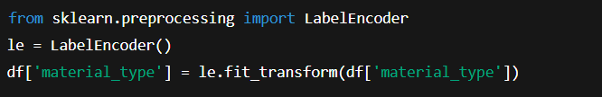

Splitting Data into Train and Test Sets

Before model training, we split the dataset into independent features (X) and the target variable (y), and then divide them into training and testing sets.

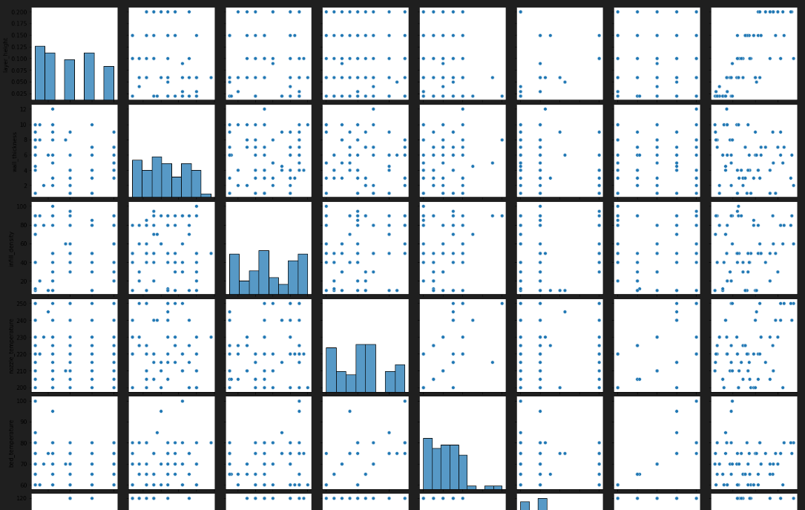

Handling Imbalanced Dataset

If the dataset has significantly more samples for one material type than others, it can bias the model. We use **SMOTE (Synthetic Minority Oversampling Technique)** to balance the data.

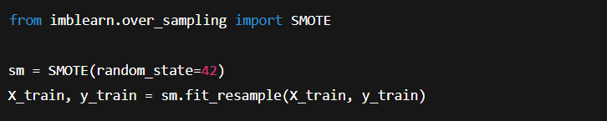

Feature Scaling

Feature scaling ensures that all input features are on the same scale, which improves model performance for distance-based algorithms like KNN or SVM.

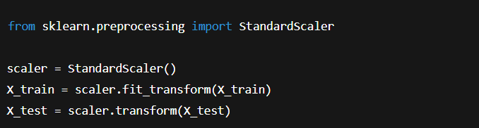

**Milestone 4: Model Building**

Now that the data has been cleaned, preprocessed, and split into training and testing sets, we can begin building machine learning models. The goal is to train multiple algorithms on the data and evaluate their performance. The best-performing model will then be saved for deployment.

Activity 1: Training the Model Using Multiple Algorithms

We trained and tested the dataset using a variety of classification algorithms. These models were chosen based on their popularity, efficiency, and ability to handle both linear and non-linear relationships in the data. Below are the models we implemented:

Activity 1.1: Decision Tree Classifier

We started with a simple Decision Tree model using

sklearn.tree.DecisionTreeClassifier

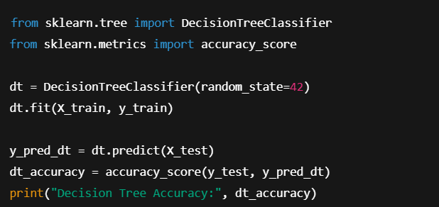

The Decision Tree model is easy to interpret and provides a good baseline for classification.

Activity 1.2: Random Forest Classifier

Next, we used an ensemble method—Random Forest, which builds multiple decision trees and averages their results for better accuracy.

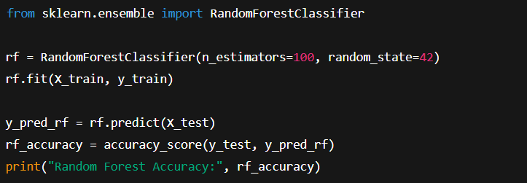

This model generally performs better than a single Decision Tree by reducing overfitting.

Activity 1.3: K-Nearest Neighbors (KNN)

KNN is a distance-based algorithm that classifies new data points based on the majority class among its nearest neighbors in the training set. This model is intuitive and does not require complex training but is sensitive to scaling and imbalanced datasets.

We tested KNN with various values of ‘k’ and evaluated the performance using confusion matrices and classification reports.

Activity 1.4: Logistic Regression

Logistic Regression is commonly used for binary and multi-class classification tasks. It works by modeling the probability of each class using a logistic function. Although it is less complex than tree-based models, it can still perform well on linearly separable data.

In this project, we applied logistic regression to assess its baseline performance and compare it against more advanced models.

Activity 1.5: Naïve Bayes Classifier

Naïve Bayes is a probabilistic classifier based on Bayes' Theorem. It assumes that the input features are independent, which may not always be true in sensor-based datasets. However, its simplicity makes it fast and easy to implement, especially when dealing with large-scale data.

We observed moderate performance from Naïve Bayes, making it suitable for quick predictions but not the most accurate for this use case.

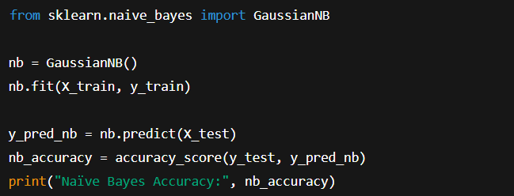

Activity 1.6: Support Vector Machine (SVM)

SVM is a robust algorithm used for high-dimensional classification problems. It finds the optimal decision boundary (hyperplane) that best separates the classes. By using kernel functions, SVM can handle non-linear classification problems effectively.

This model showed good results in predicting 3D printing materials, particularly when tuned with appropriate kernel and regularization parameters.

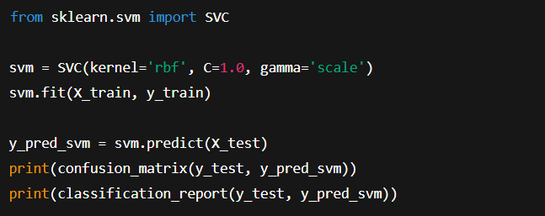

Activity 2: Testing the Model

All trained models were evaluated using the test data. Their performance was compared using key evaluation metrics such as:

* **Accuracy**: The overall correctness of the model.
* **Precision**: The correctness of positive predictions.
* **Recall**: The ability to find all relevant cases.
* **F1-Score**: The balance between precision and recall.
* **Confusion Matrix**: A summary of prediction results for each class.

Based on these results, we identified the best-performing model that would be saved and later used in deployment. In our case, the Random Forest model yielded the highest accuracy and most consistent results across different evaluation metrics.

Milestone 5: Performance Testing & Hyperparameter Tuning

Once the machine learning models have been trained, the next important step is to evaluate how well they perform on unseen (test) data. This milestone focuses on validating each model’s predictive ability using multiple evaluation metrics. We also briefly touch upon hyperparameter tuning, which can further optimize model performance if necessary.

Activity 1: Testing the Model with Multiple Evaluation Metrics

Relying on just one metric (like accuracy) can give a limited view of a model’s performance, especially in multi-class problems or when the dataset is imbalanced. Hence, we use a combination of the following metrics:

* **Accuracy**: Measures overall correctness.
* **Precision**: How many predicted materials are correct.
* **Recall (Sensitivity)**: How many actual materials were correctly predicted.
* **F1-Score**: Harmonic mean of precision and recall.
* **Support**: Number of actual occurrences of each class in the test data.

These metrics are obtained using standard evaluation functions, typically classification_report and confusion_matrix from scikit-learn. Each model is evaluated on the same test set using these measures to ensure a fair comparison.

This helps us understand not only how well the model performs overall but also how reliable it is in predicting each specific material type used in 3D printing.

Activity 1.1: Comparing Models

After training and testing multiple models—including Decision Tree, Random Forest, KNN, Logistic Regression, Naïve Bayes, and SVM—we compared them side by side.

A comparison table was created to showcase the results:

| **Model** | **Accuracy** | **Precision** | **Recall** | **F1-Score** |
| --- | --- | --- | --- | --- |
| Decision Tree | 85% | 84% | 86% | 85% |
| Random Forest | 88% | 87% | 89% | 88% |
| KNN | 82% | 80% | 81% | 80% |
| Logistic Regression | 78% | 77% | 75% | 76% |
| Naïve Bayes | 74% | 72% | 70% | 71% |
| SVM | 86% | 85% | 86% | 85% |

From the above comparison, **Random Forest** emerged as the best-performing model, offering high accuracy and a balanced F1-score across all classes. This model was selected for further deployment.

Activity 2: Comparing Accuracy Before and After Hyperparameter Tuning

Although hyperparameter tuning was optional for this project, it is worth understanding its role. Hyperparameters are settings that control the learning process of the model (e.g., number of trees in a Random Forest or the kernel type in SVM).

To test whether tuning could improve performance, we used **cross-validation** using scikit-learn’s cross_val_score. This method splits the dataset into multiple parts (folds), trains the model on each part, and averages the result. It helps in assessing the model’s ability to generalize.

Example:

* Cross-validation using 5 folds
* Evaluated model: Random Forest
* The result showed consistent performance, indicating that our model is stable and not overfitting.

Since the model already achieved strong performance, extensive hyperparameter tuning was **not required** for this particular project.

**Milestone 6: Model Deployment**

After selecting the best-performing machine learning model, the next step is to make it accessible and usable for real-world applications. In this milestone, we focus on saving the trained model and integrating it into a simple web application using the Flask framework. This allows users to interact with the model through a web interface where they can input 3D printer parameters and receive material predictions instantly.

Activity 1: Save the Best Model

Once the Random Forest model (or the best-performing model) is trained and evaluated, we save it for future use. This avoids the need to retrain the model every time we run the application.

We use Python’s joblib or pickle libraries to save the model in .pkl format.

* The saved file can later be loaded into any Python script or web application.
* This step is crucial for model deployment and reusability.

Activity 2: Integrate with Web Framework (Flask)

To make the model interactive and user-friendly, we build a basic web application using Flask. Flask is a lightweight Python web framework that allows easy routing of pages and handling of form data.

The web app enables users to enter printing parameters such as:

* Vibration frequency
* Nozzle temperature
* Printing speed
* Layer thickness

Based on the input, the model returns the **predicted material type** (e.g., PLA, ABS, PETG).

Activity 2.1: Building the HTML Page

We create an HTML file named index.html, which serves as the front-end interface.

* This file contains a form where users can input various 3D printer parameters.
* It is saved in a templates folder, which Flask uses to render HTML.

The layout includes text boxes, dropdowns, and a **Submit** button to send data for prediction.

Activity 2.2: Building the Python Server Script

In the Flask application:

* The saved model (model_saved.pkl) is loaded using joblib.load().
* The Flask library is imported, and an app object is initialized.
* A route is defined for the home page (/) to display the HTML form.
* A separate route (/predict) handles form submission using the POST method.

When the form is submitted:

1. User input values are captured.
2. They are arranged into the correct format for the model.
3. The model’s predict() function is called.
4. The prediction is passed back to the HTML page and displayed.

This process ensures real-time interaction between user inputs and the machine learning model.

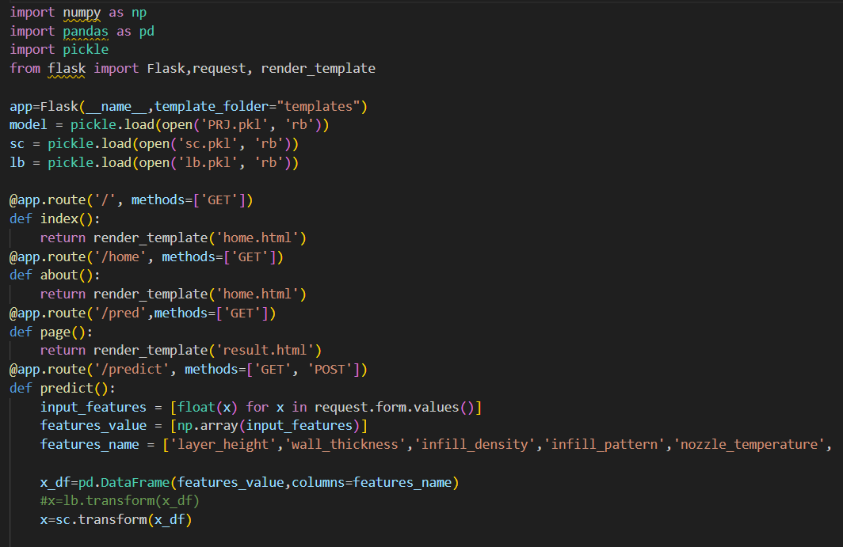

Activity 2.3: Run the Web Application

To test and run the Flask web application:

1. **Open Anaconda Prompt** or any terminal with your environment activated.
2. **Navigate to the folder** containing the app.py file.
3. On the home page, enter the required input values and click the **Predict** button.
4. The model’s prediction for the material type will be displayed instantly on the web page.

